Name: Vishnu Mohan
Roll No: 51
Batch: MCA B
Date: 02-06-2022

NETWORKING & SYSTEM ADMINISTRATION LAB

Experiment No.: 25

Aim
To familiarize with the installation of netcat
Procedure
1. Open the terminal on Ubuntu
2. Install netcat
Sudo apt –get install netcat
Output:-
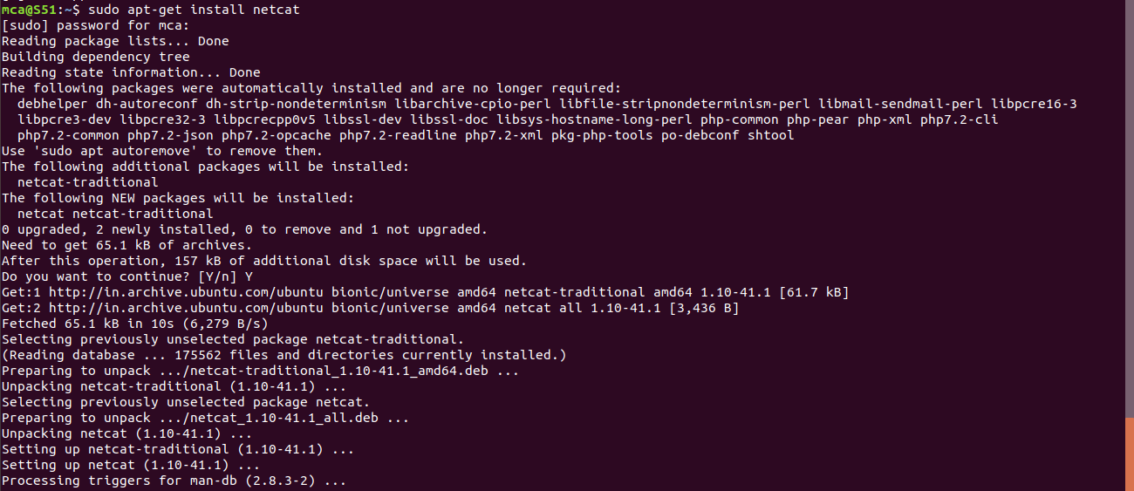
3. To set up the server using Netcat in listening mode. We will use port 12345 and will specify the port number with the -p option.
nc –l –p 1234
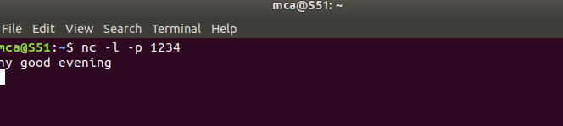
Output:-

4. nc localhost 1234 : The client needs the server ip to connect to it. My server and my client are on the same machine so I use localhost for the hostname. The command ‘nc hostname port’ puts Netcat in client mode and connects to the specified hostname on the specified port.
Output:-


